Benefits of Membership  1. Columbia Magazine - Free subscription to the Order’s award-winning magazine examining issues of concern to Knights, Catholics and families.  2. Knights of Columbus rosary - Blessed by the supreme chaplain, presented during the Admission Degree to each new member  3. Daily Mass of Remembrance at St. Mary’s Church - Mass for deceased members and their wives at the birthplace of the Order  4. Insurance - Access to a portfolio of top-quality life insurance, long-term care and annuity products exclusive for members and their families.  5. Family Fraternal Benefit - For eligible families: a) pays $1,500 for the child who dies before the age of 61 days; b) pays $750 for the child who is stillborn at least 20 weeks after conception; c) offers guaranteed-issue insurance - up to $5,000 - to any child under age 18  6. Orphan Benefit - $80 monthly allotment for orphans of eligible families; up to $7,000 in college scholarships available  7. Member/Spouse Fraternal Benefit - Accidental death coverage for member & spouse at no cost  8. Widow Benefits - a) continues to be covered under the Member/Spouse Fraternal Benefit; b) may purchase life insurance, long-term care insurance or annuities up to one year after insured member’s death; c) receives a free lifetime subscription to Columbia; d) eligible with her children for scholarships, student loans, etc.  9. Scholarships - Scholarship programs for higher education available to members, their spouses and children. | Our focus is to help our Church thru  our time and talent, supporting the  activities and projects that promote  increased spirituality and Parish unity.  We also support the Catholic  Community through acts of charity.  Many hands help spread the work  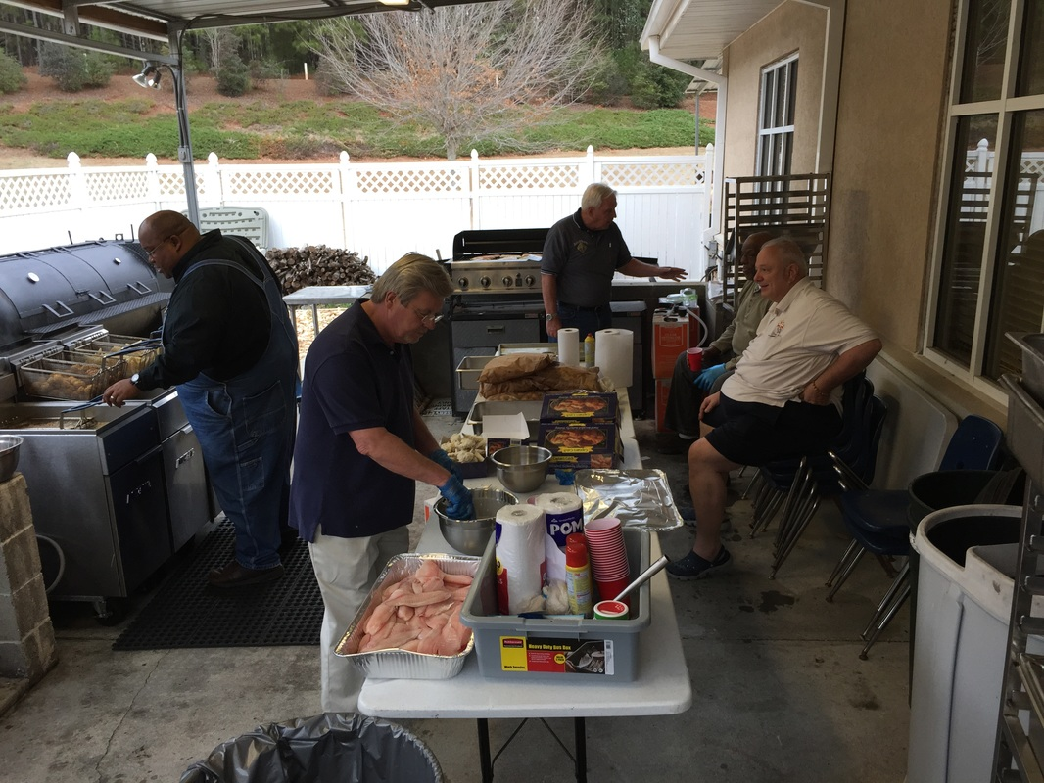  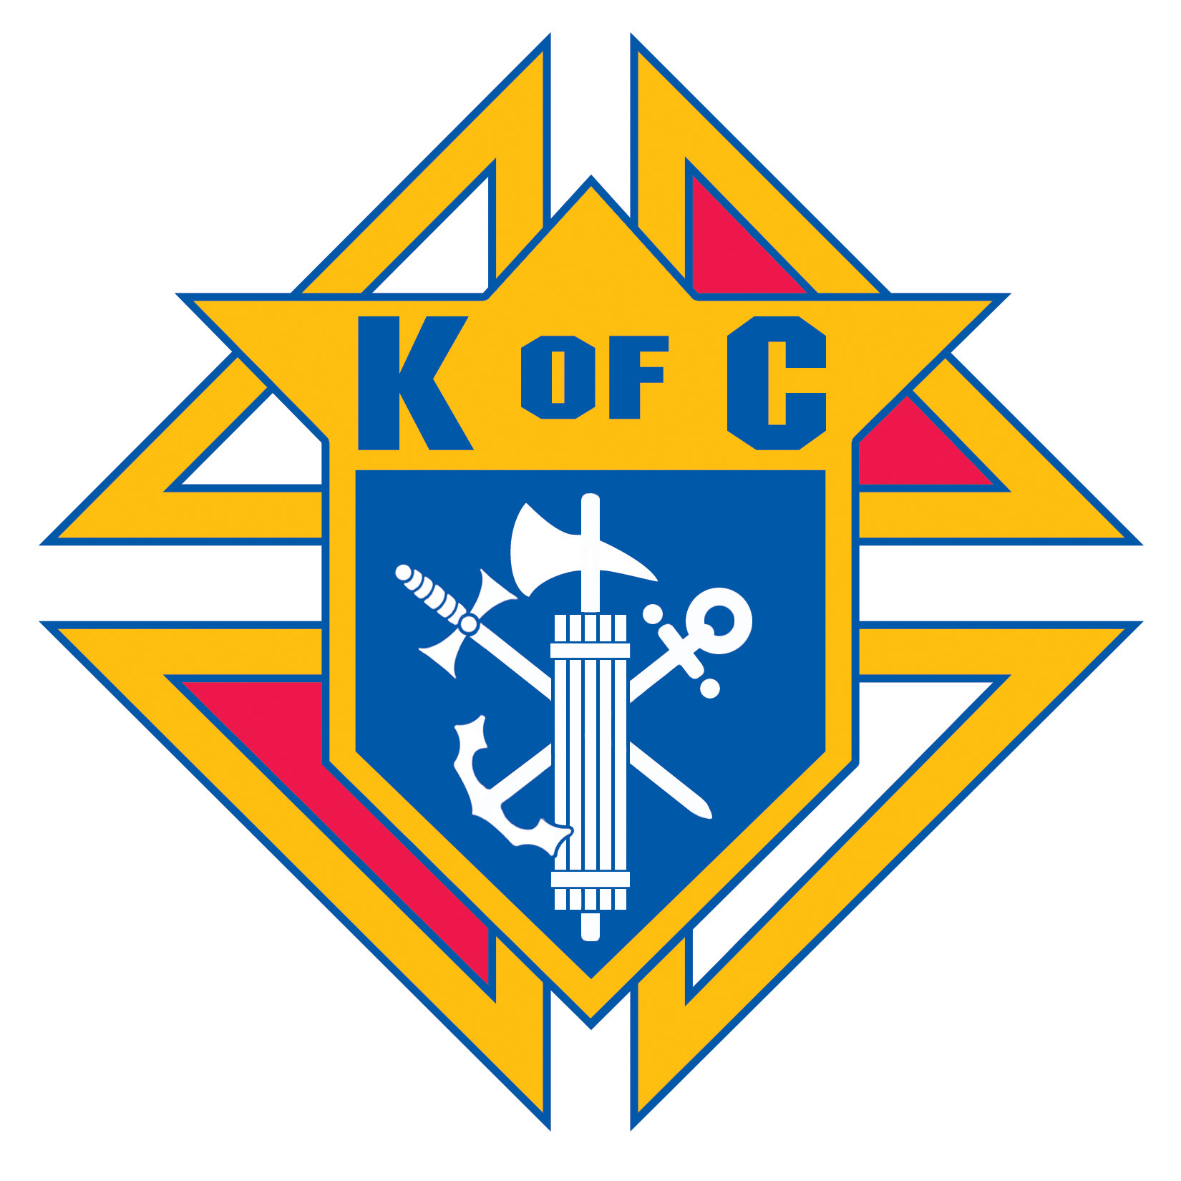  Come Join Us! | Knights  Of  Columbus  Council #14122  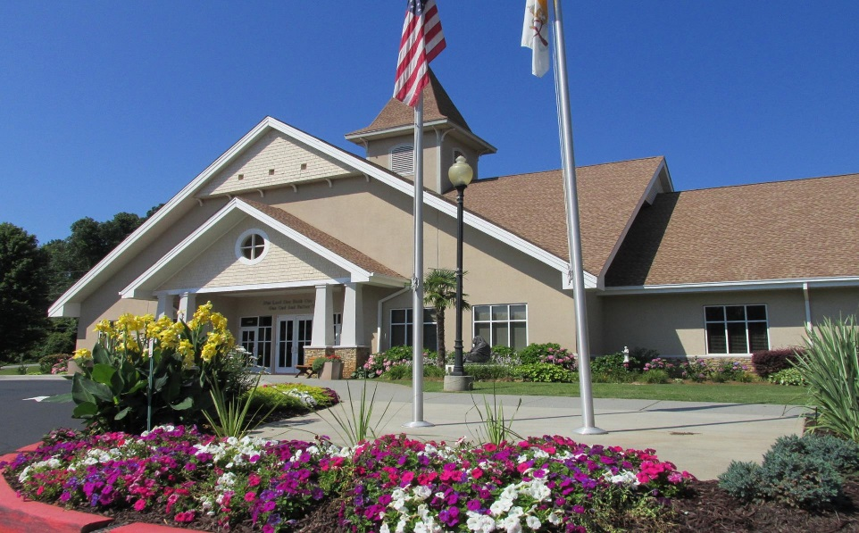  Charity, Unity, Fraternity, Patriotism  Founded 2006 at  St. Stephen the Martyr Catholic Church  Lilburn, Georgia  For more information, please contact:  Stephen Orey  678-754-1105  stephen.orey@gmail.com  We meet every 1st Tuesday of the month at the Parish  Visit our website: ststephenkofc.weebly.com
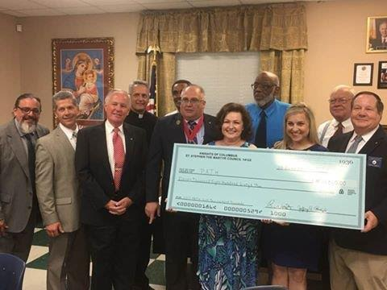  Charity Golf Tournament  All proceeds from our Golf Tournament go to Charities that share the church’s beliefs. Pictured above is the donations raised for the PATH Charity in 2017.  Feed those working to protect us  Prepared Pork Bar-b-que for local Firefighters and Police protecting us on Super Bowl Weekend.  Ultrasound Machine  In 2014 purchased an Ultrasound machine for a Women’s clinic that is now saving the unborn and assisting with Women’s Health issues.  Monthly Breakfast  On the third Sunday of every month except June & July, KOC prepares a breakfast after 8:30am Mass for parish community outreach. | Supporting our Parish and Community  • The KOC have been Hosting/Preparing Meals /Helping Facilitate  “That Man is You” – weekly Men’s program each week in the Fall and Spring since 2015  • Lenten Devotional/Educational Material  • Parish Grounds Beautification, Garden and Landscaping Improvements  • Parish/Church Enhancements – The KOC donated the Mary/Joseph Statues.  • Mother’s Day Flowers  • Father’s Day Gifts  • Veterans Appreciation  • All Souls Day Commemoration Table  • Thanksgiving Baskets for the Needy  • Christmas Baskets for the Needy  • Angel Tree Christmas Gifts for the Needy  • Lenten Fish Dinners / Stations of the Cross  • Super Bowl BBQ  • FALL Parish Picnic Hosts  • Sponsors for the Annual Lifeteen Stuebenville Retreat  • Vacation Bible School Lunches  • Helping with Summer Mission Week for Teens  • Seminarian Sponsorship  • Providing Color Guard for the Spring Confirmation with the Bishop.  • Pregnancy Aid Clinic Fundraiser Sponsor | Breakfast with Santa  Hold a free breakfast for the parish and provide all the children with a picture with Santa.  Sunday Rosary  Once a quarter gather with the parish to pray the rosary.  Food for Families  Every meeting men bring cases of food that is delivered to the Lilburn Food Co-op. This year’s goal is 5000 pounds of food.  Dues  We do collect nominal annual dues, a portion of which supports National, State and International projects such as Disaster relief, Special Olympics, Papal projects  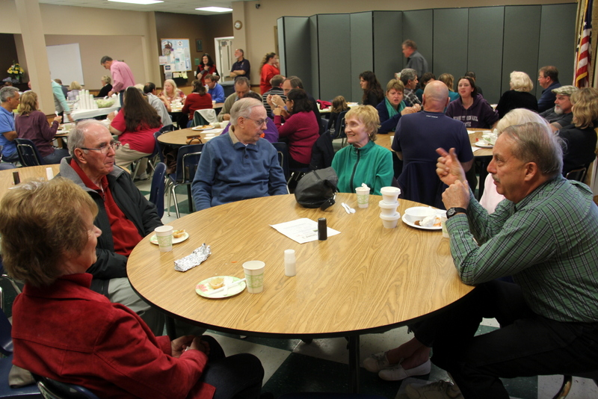  Lenten Fish Dinners

